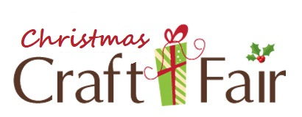

Name:
Address:
Phone(s):
Cost per table is $30 (Non-refundable). Number of tables requested:

All entries displayed will be in a clean and Christian manner.
Items to be entered:

I, ______________________________________, understand that all items entered will be new and homemade.

I understand that all setup and tear down of my area is my responsibility, and I will leave the facility in the same condition as I received it.

I and anyone accompanying me agree to conduct myself in a Christian manner with a positive attitude. I (We) will abstain from using foul language, drugs, and/or alcohol while on the property of Oak Grove Baptist Church.

I and anyone accompanying me will not hold Oak Grove Baptist Church responsible in case of an accident causing injury.

Signature
Today’s Date

